- CH01-MU01 — System Overview Conceptual Diagram. Figure 1. System Overview of the VIRON Method.

CH02-MU01 — Layer Separation Diagram. Figure 2. Separation of Functional Layers in the VIRON System

CH02-MU02 — Layer Interaction Diagram. Figure 3. Interaction Between Functional Layers in the VIRON System
- CH03-MU01 — Notes Sidebar Folder Layout.
- CH03-MU02 — Idea Inbox Note Structure
- CH03-MU03 — Projects Folder with 3 Active Projects
- CH03-MU04 — Library Folder with Atomic Notes
- CH03-MU05 — Notes Settings Configuration
- CH03-MU06 — Apple Intelligence ChatGPT Extension Enabled
- CH04-MU01 — Clean Reminders List
- CH04-MU02 — Reminders Project-Specific Task View
- CH05-MU01 — Quick Capture Shortcut Flow
- CH05-MU02 — Send to Reminders Shortcut. Explanation text: “This shortcut converts a processed idea into an actionable task. When reviewing items in the Inbox, highlight any text that represents a concrete action and run the Send to Reminders shortcut. The selected text becomes the title of a new reminder in the VIRON Tasks list. Only items that require execution should be sent to Reminders. Everything else remains in Notes for reference, development, or archiving. This maintains a clear boundary between ideas and commitments.”
- CH05-MU03 — Daily Planning Shortcut. Explanation text: “This shortcut displays all unfinished tasks and allows you to select the ones that will be completed today. The selected tasks are automatically assigned a due date of today, causing them to appear in the Reminders “Today” view. This creates a lightweight daily planning ritual without requiring a separate planning tool.”
- CH05-MU04 — Weekly Reset Shortcut. We will not include this screenshot, instead add this text – “Weekly Reset is performed directly inside Apple Reminders rather than through automation. The goal of the reset is to review unfinished work, remove stale urgency, and restore clarity before the next week begins. By reviewing the key reminder views in sequence, you ensure that no task is forgotten and that the coming week starts with a realistic plan.

Weekly Reset Steps
- Review Inbox
Process captured items and move them into the appropriate project list.
- Review Today
Complete finished tasks and reschedule anything that was not completed.
- Review Scheduled
Confirm that upcoming tasks still belong on the dates assigned to them.
- Review Flagged
Remove flags that are no longer important and keep only the items that still require special attention.
- Review VIRON Tasks
Return to the master task list and confirm that it reflects the work that actually matters going into the next week.”
- CH05-MU05 — Shortcut Architecture Concept Diagram. Figure X. Shortcut Automation Within the VIRON System Architecture
- CH06-MU01 — Weekly Review Structure Overview. Figure X. Structure of the Weekly Review Process
- CH07-MU01 — Unified Architecture Diagram. Figure X. Unified Architecture of the VIRON System. Add this text after diagram – “Unified Architecture Diagram
The VIRON system separates capture, organization, execution, and knowledge into distinct layers. Ideas enter through the Inbox, become structured work through projects and tasks, and ultimately evolve into long-term knowledge within the Library. This architectural separation preserves clarity and prevents systems from collapsing under complexity.”
- CH08-MU01 — Library Folder (Mature State). Figure X. Mature Folder Structure of the VIRON Knowledge Library. Add this text “Over time, completed work produces insights. The Library becomes a structured collection of atomic notes that capture principles, observations, and lessons learned from projects.”.

CH09-MU01 — Failure Mode Example. Figure X. Failure Mode When System Layers Are Skipped

CH13-MU01 — Maturity Model Diagram. Figure X. Maturity Model of the VIRON System

CH14-MU01 — Team Adaptation Diagram

CH15-MU01 — 90-Day Roadmap. Figure X. 90-Day Roadmap for Implementing the VIRON System

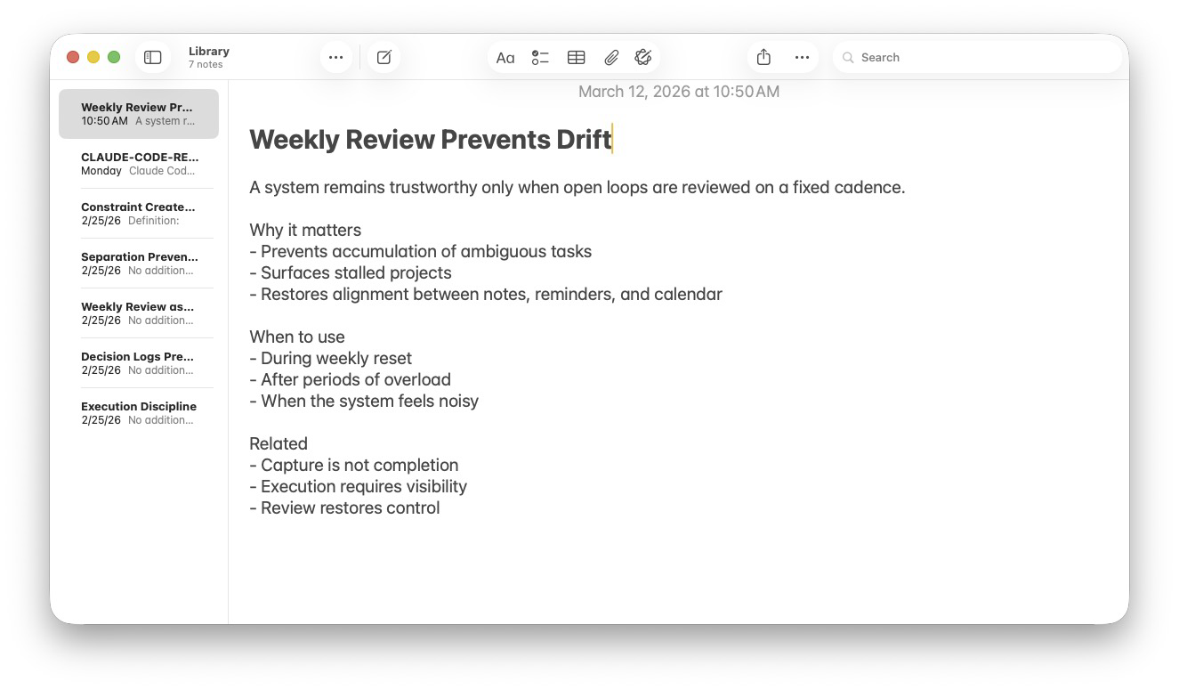
Caption: Figure 8 — Example of a refined Library knowledge note.
Ideas in the Library are distilled into short, reusable principles
that guide execution and decision-making.

figures/ui-mockups/CH08-MU02-refined-knowledge-note.png

Figure 14 — Shared Execution Layer.
Team decisions and inputs are converted into visible tasks
in a shared execution system where work is assigned and tracked.

CH14-MU01-shared-execution-layer.png.png

Figure 14 — Shared Team Library.
Teams maintain a shared knowledge repository where durable
principles, processes, and templates are refined over time.

figures/ui-mockups/CH14-MU02-shared-team-library.png

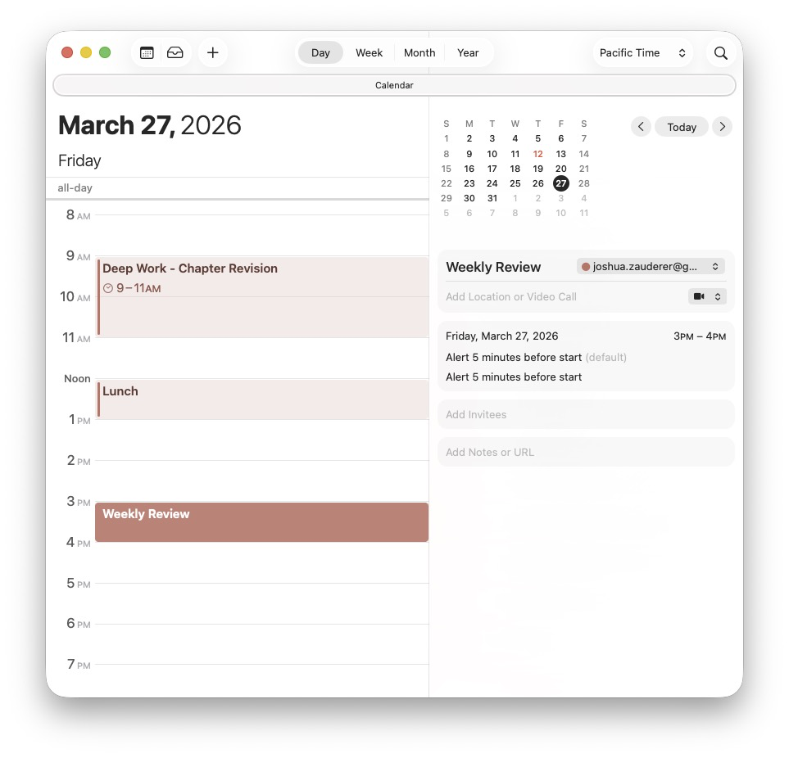
CH16-MU03-calendar-calm-state

figures/ui-mockups/CH16-MU01-notes-calm-state.png

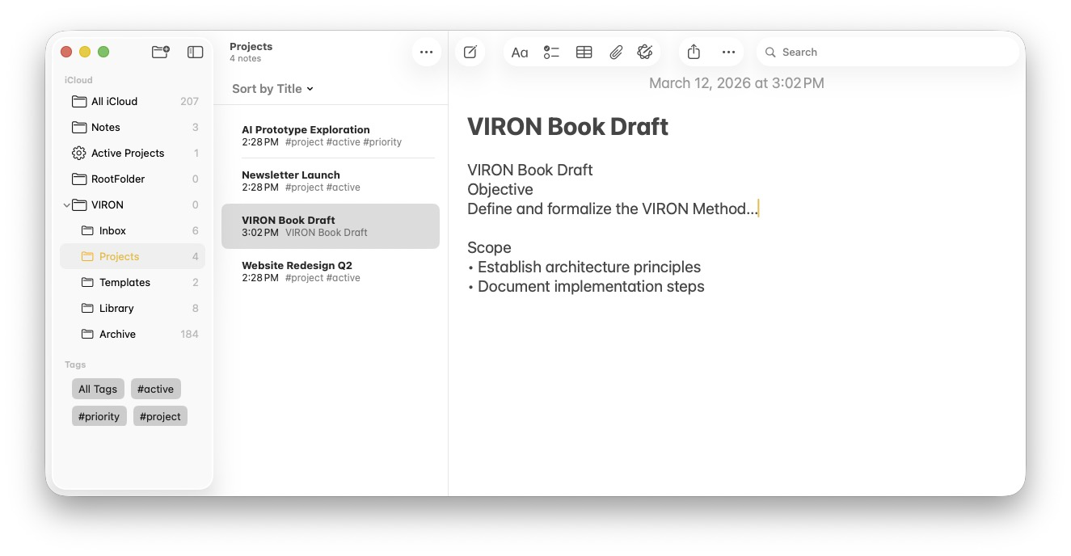
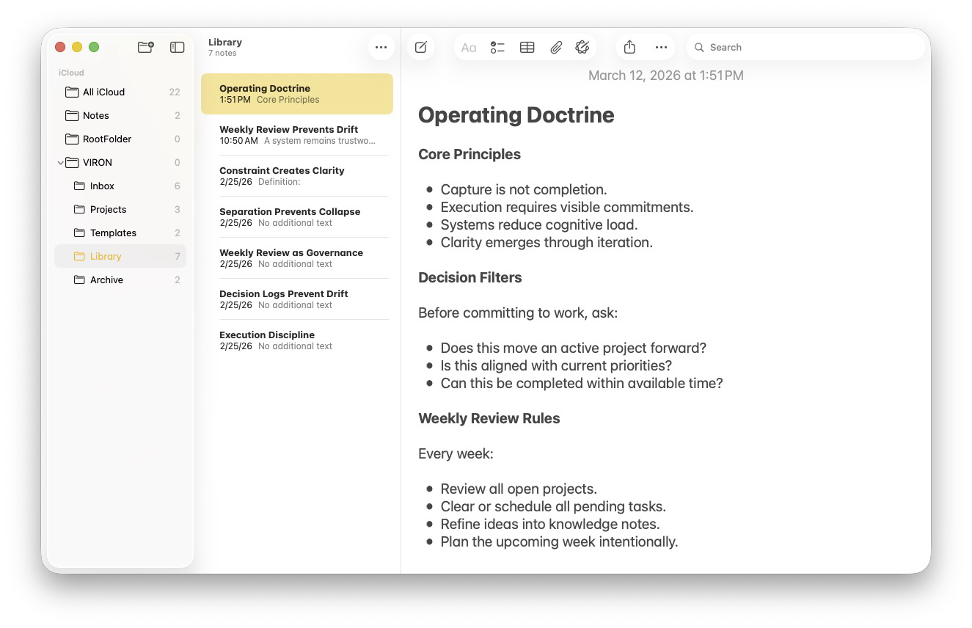

figures/ui-mockups/CH10-MU01-personal-doctrine-note.png

figures/ui-mockups/CH16-MU02-reminders-calm-state.png

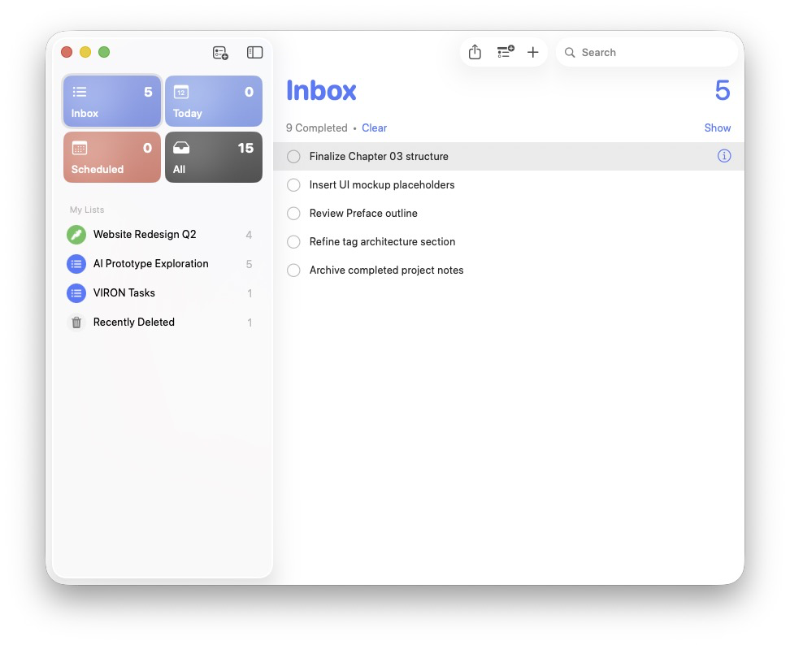
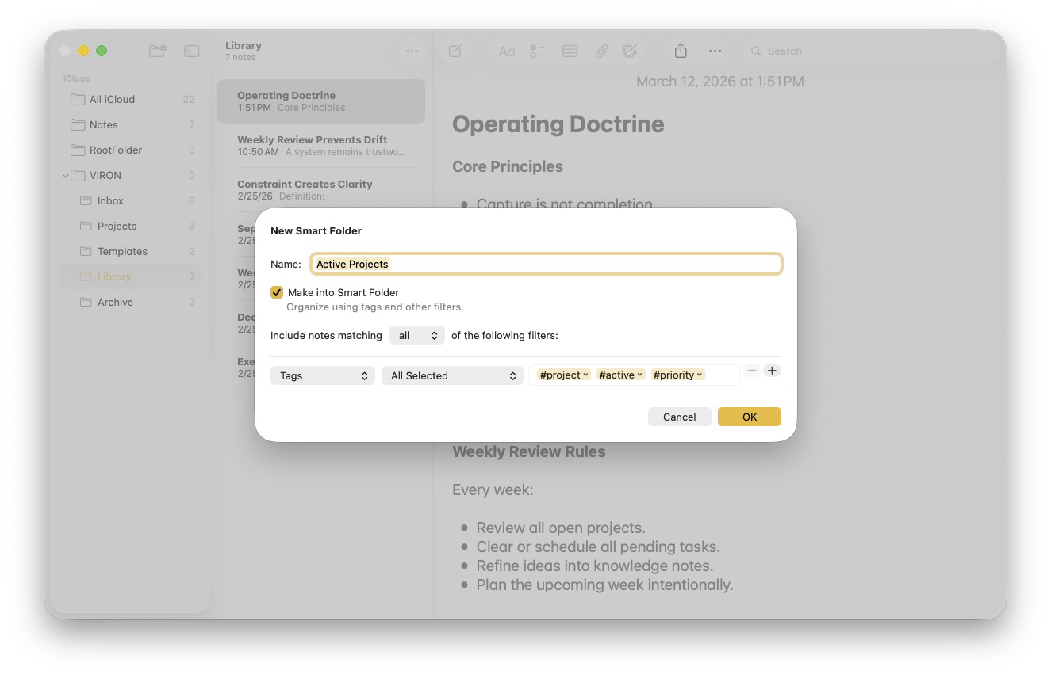

figures/ui-mockups/CH11-MU01-smart-folder-creation-modal.png

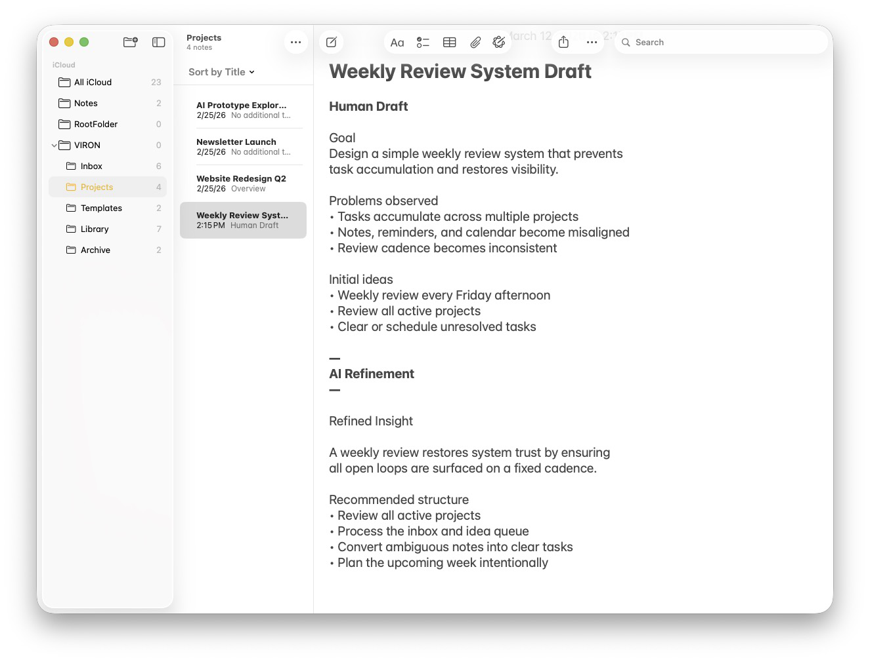

figures/ui-mockups/CH12-MU01-structured-note-ai-output.png

figures/ui-mockups/CH11-MU02-smart-folder-result-view.png

